Payroll Management System for Information Technology Company

Version 1.0

Revision History

|  |  |  |  |
| --- | --- | --- | --- |
| **Date** | **Version** | **Description** | **Author** |
| 31/10/2019 | 1.0 | Final | Tạ Văn Hiệp |
|  |  |  |  |
|  |  |  |  |
|  |  |  |  |

Table of Contents

1. View Feedback 4

1.1 Brief Description 4

1.2 Actor Accountant. 4

2. Flow of Events 4

2.1 Basic Flow 4

3. Special Requirements 5

4. Preconditions 5

5. Postconditions 5

6. Extension Points 5

# View Feedback

## Brief Description

This use case defines steps of view feedbacks of employees in the system. Accountant can

easily view feedbacks in the database.

## Actor Accountant, administrator and employee.

# Flow of Events

## Basic Flow

The system accountant selects to view feedback and click all button “View all feedback”.

All feedbacks of employees which is stored in database system are shown such as a table with fields (id, username, user id, title, description, status, postdate and process date). Account knows all information about each feedback.

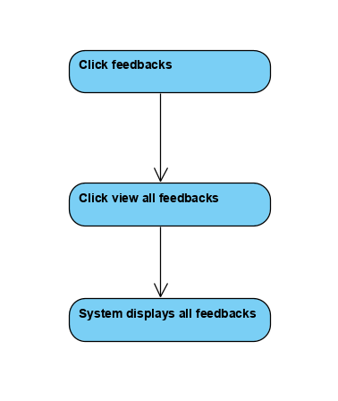



Basic flow of view feedbacks

# Special Requirements

No special requirements.

# Preconditions

Login.

# Postconditions

There are feedbacks of employees, no feedback will be shown if no feedback in database.

# Extension Points

Account can search feedback by id.